An Saol Project (Day Centre)
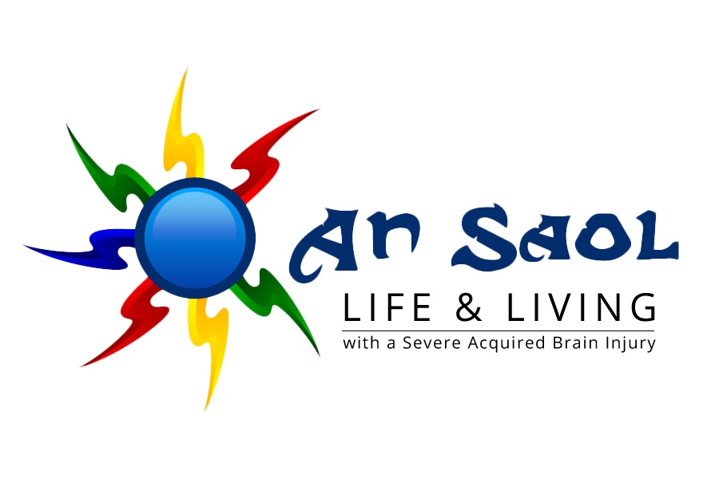
Expression of Interest

This form is for families affected by a severe Acquired Brain Injury (sABI) and who would like to express an interest in joining the An Saol Project. Please return to: An Saol Foundation, Expression of Interest, Carmichael House, North Brunswick Street, Dublin 7.
All information provided in this form will be treated confidentially and only be made available to those involved in the processing of this expression of interest, i.e. the Admissions Committee, including medical advisors.
1. Your contact details

Your first name Your second name

Your email Your mobile phone

Your address
2. Contact details of the person with the sABI

First name Second name

Where are they currently? Age
3. Treating General Practitioner (GP) or Consultant (C)

Name of GP/C Telephone of GP/C

Address of GP/C
4. Further details about the person with sABI

What caused the sABI? When did the sABI occur (year)?

Are they medically stable? Yes/No Do they avail of rehab services? Yes/No

Can they speak? Yes/No Can they hear and understand? Yes/No

Can they eat? Yes/No Can they drink? Yes/No

Voluntary movements? Yes/No Functional vision? Yes/No

Can they communicate? Yes/No If yes, briefly describe how:

Would they be able to attend the Day Centre five days a week? Yes/No

How would they travel to and from the Day Centre?

Are they able to travel by air? Yes/No/Don’t know

Would you be available to attend regular training and support sessions for family members/close friends in the Day Centre? Yes/No

Date: Signature:
Thank you for your interest! We will contact you in the near future to arrange a meeting.
20181210

